Camp ReFuel 2026
LTN/CWS REGISTRATION CAMP DATES MARCH 20-22, 2026
(For grades 6-12)

Camper Name _____________________ (Name called) _____________ Age ______ T-shirt size _______
Boy Girl Current School Grade __________ Name of School _______________________
Parent or Guardian _____________________________________________________________________
Address ______________________________________________________________________________
City ______________________________________ State ___________ Zip _______________________
Home Phone ( ) _____________________ Cell Phone ( ) __________________________________
Email Address ______________________________________ Church Affiliation ____________________
Cabin Friends ** _______________________________________________________________________
** ( Limit to two and must be requested by all families. )

In Case of Emergency Notify ___________________________________ Phone ( ) _________________
Parent or Guardian Signature ______________________________________________________________

CAMP WILLOW SPRINGS – 102 Camp Willow Springs Drive, Littleton, NC 27850 PH. 252-586-0728
REGISTRATION FEE $45.00. CWS Medical statement is required. Adults/Chaperones camp fee is $45.00.
Registration, medical statement and fee may be mailed to: LTN 162 Reed Circle South Hill, VA 23970
Make checks payable to LTN Ministries. Your reservation is confirmed once we have received the registration form, medical statement and payment.

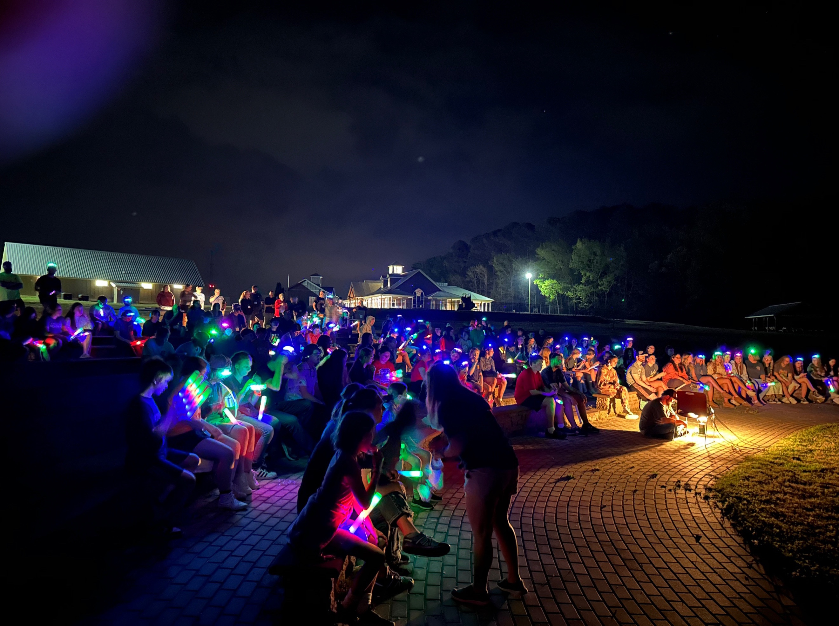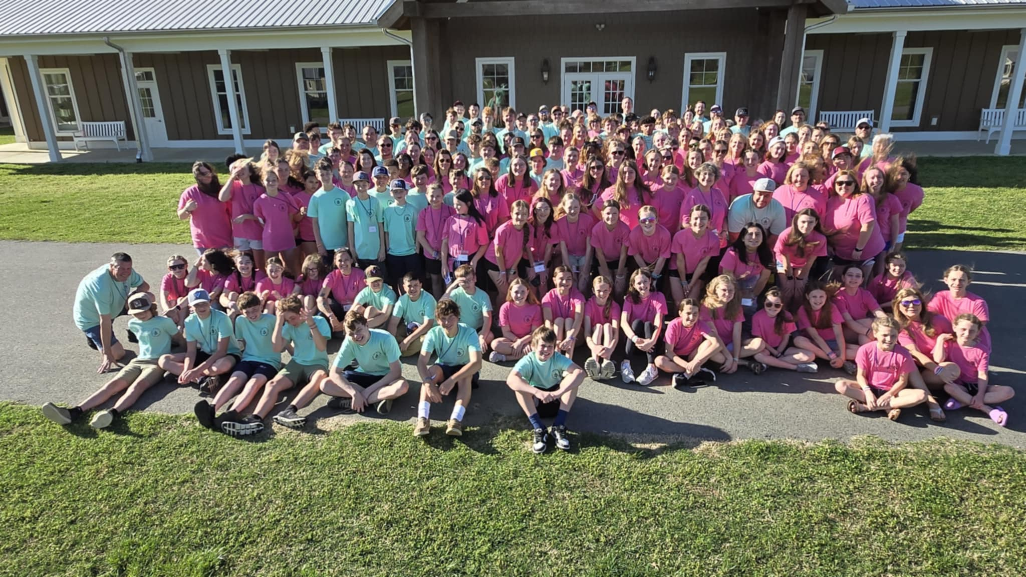

RECREATION ACTIVITIES

Each camper will have the opportunity
To participate in the following activities:
Cost includes:
2 nights lodging, 5 meals, full program and t-shirt.

Check-in -Friday 5:00 p.m. 03/20/2026
Camp ends – Sunday
12:00 p.m. 03/22/2026
- Canoeing • Low Ropes Course
- Field Games • Jumping Pillow
• Climbing wall/Giant swing

LTN = Light the Night Ministries Email: denny@lightthenight.net
CWS = Camp Willow Springs LTN Website: www.lightthenight.net

